Malla Reddy College of Engineering & Technology
(UGC autonomous Institution, Approved by AICTE and NBA Accredited, NAAC A Grade Institution)
B.Tech-III Year – II Semester(R15) | MID-I Examinations – August 2018
SOFTWARE ENGINEERING

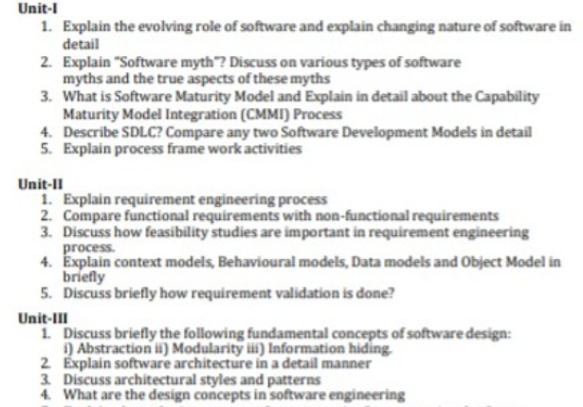
5.Briefly explain user interface and design
6.Explain Object Oriented Design Process
7.Explain about Object Oriented Analysis.

Unit-IV
- Explain about the importance of test strategies for conventional software.

Differentiate black box testing with white box testing and Compare Alpha Testing with Beta Testing.
- Describe Art of Debugging process.
- Demonstrate metrics.

Unit-V
- Define Risk management Reactive vs Proactive Risk Strategies, How they risk will be identified and Explain the RMMM Plan inbrief.
- Classify software quality assurance (or) Software Reliability Growth Models.
- Identify different ISO 9000 quality standards.
- Explain following terms
- Software Reviews
- formal technical reviews.
- Explain about Risk Assessment

